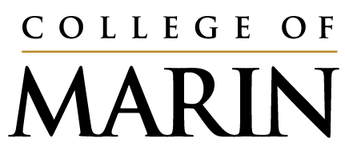

MANAGER SUPPLEMENT FOR THE

POSITION DESCRIPTION QUESTIONNAIRE

Please carefully review the completed employee Position Description Questionnaire (PDQ) and be sure that it gives a complete and accurate picture of the employee’s responsibilities, job requirements and working conditions.

Please do not edit, modify or change the employee’s questionnaire. Since this is not a performance review, do not address employee performance.

All completed PDQs and Manager Supplements must be delivered to Connie Lehua, Manager Employee and Labor Relations, through the OneDrive folder no later than August 31, 2023.
IMMEDIATE MANAGER’S REVIEW

Name and classification of the PDQ being reviewed:
Employee Name: | Classification Title:

- Do you agree the employee’s questionnaire provides a complete and accurate description of the job?
Yes No If no, please explain or amplify.

- Please provide here any additional narrative to the employee’s “Job Purpose” section that will further assist the consultants in understanding the context of the employee’s job and its key accountabilities.

- What do you consider this position’s most important responsibility or performance result?

- Are there certifications, licenses or special training that are essential for performing the duties of this position, beyond those listed by the employee? If yes, please list below. Are any of the certifications, licenses or special training listed by the employee desirable, but not mandatory?
Yes No

- Describe briefly the three most important knowledges and skills you believe are necessary for successful job performance.

- Are you aware of employees in other classification titles performing work very similar to this position? If yes, please list these employees and job titles.

Do you believe this position is in the right classification/job title? Yes No
If No, what are your reasons and what classification do you believe would be more appropriate?

- Other comments.

Manager Signature Date _________________________________________

Manager Name Title

